Secure 3‑Tier Python Application on Azure

Project Title
Secure 3‑Tier Python Application on Azure using App Services and Private Endpoint–Enabled Azure SQL

1. Project Overview
This project demonstrates the end-to-end implementation of a secure 3-tier application architecture on Microsoft Azure using Python-based App Services and Azure SQL Database secured with Private Endpoints. The goal is to showcase how modern cloud-native applications can be deployed with strong network isolation, minimal public exposure, and best practices for security, scalability, and maintainability.
The solution separates concerns into three distinct tiers: - UI Tier – Flask-based frontend hosted on Azure App Service - Backend/API Tier – FastAPI-based microservice hosted on Azure App Service - Data Tier – Azure SQL Database accessible only through a Private Endpoint
This architecture closely mirrors real-world enterprise deployments and is ideal for demos, proof-of-concepts, and learning secure Azure networking patterns.

Architecture Tiers
- UI Tier – Flask web application hosted on Azure App Service
- Backend Tier – FastAPI microservice hosted on Azure App Service with VNet Integration
- Data Tier – Azure SQL Database secured using Private Endpoint
The UI communicates only with the backend API, and the backend securely accesses the Azure SQL Database through a private IP address inside a virtual network.
📸 Screenshot Placeholder: High‑level architecture diagram

2. Technology Stack
Layer | Technology
Frontend | Flask (Python)
Backend | FastAPI (Python)
Database | Azure SQL Database
Hosting | Azure App Service (Linux)
Networking | Azure VNet, Private Endpoint
Security | Private DNS, Environment Variables

3. Application Development

3.1 Backend API (FastAPI)

Folder Structure
project3/
└── backend-api/
├── main.py
└── requirements.txt

requirements.txt
fastapi==0.110.0
uvicorn==0.27.1
pyodbc==5.1.0
pydantic==2.6.4
email-validator==2.1.1

main.py (Backend Logic)
- Exposes /health endpoint for monitoring
- Exposes /submit endpoint to store form data in Azure SQL
- Reads SQL connection string securely from environment variables
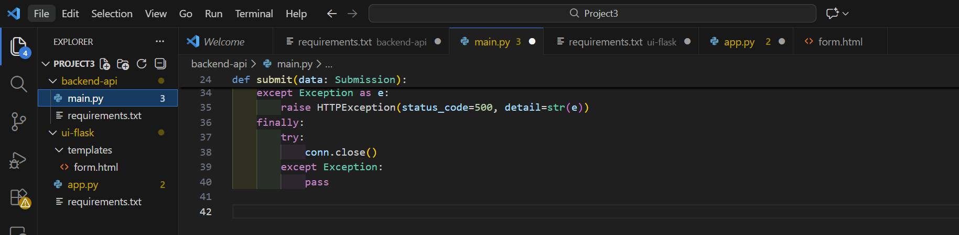

3.2 UI Application (Flask)

Folder Structure
project3/
└── ui-flask/
├── app.py
├── requirements.txt
└── templates/
└── form.html

UI Responsibilities
- Displays HTML form
- Sends form data to backend API
- Displays success or error messages
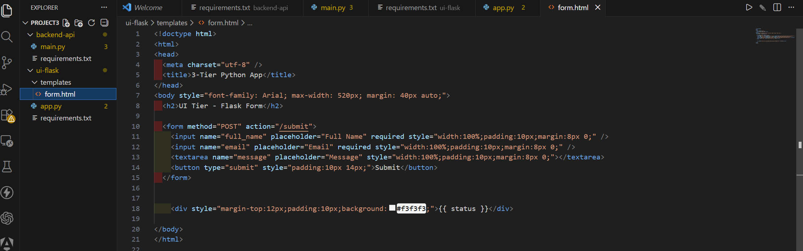

4. Infrastructure Implementation

4.1 Resource Group Creation
- Name: rg-3tier-python
- Region: Same region for all resources
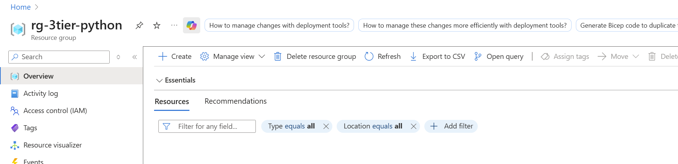

4.2 Virtual Network & Subnets
VNet: vnet-3tier (10.10.0.0/16)
Subnet | Purpose | Address Range
snet-app | App Service VNet Integration | 10.10.1.0/24
snet-pe | Private Endpoints | 10.10.2.0/24
Why VNet Integration? App Service VNet Integration allows outbound traffic from the backend App Service to securely access private resources such as Azure SQL via Private Endpoint.
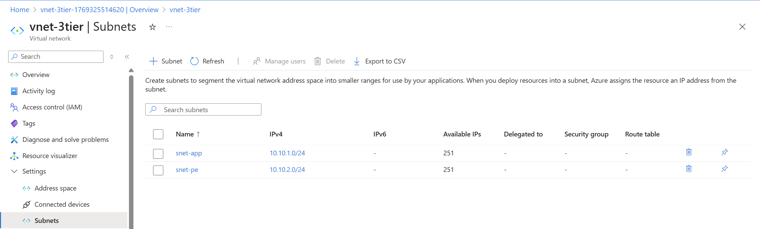

4.3 Azure SQL Server Creation
- SQL Authentication enabled
- Used for hosting private Azure SQL Database
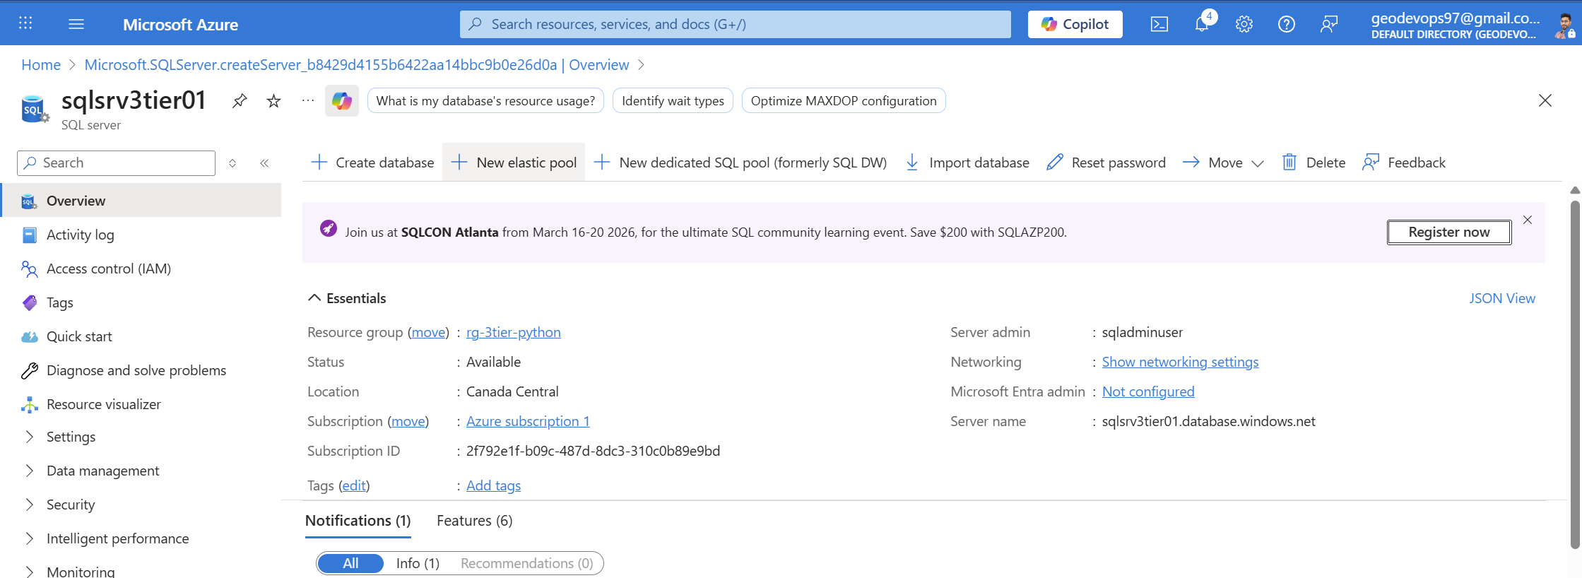

4.4 Azure SQL Database with Private Endpoint

Key Configuration
- Public network access: Disabled
- Connectivity: Private Endpoint only
- Private DNS Zone: privatelink.database.windows.net
Outcome: - Database receives a private IP - DNS resolves internally - Internet access is completely blocked
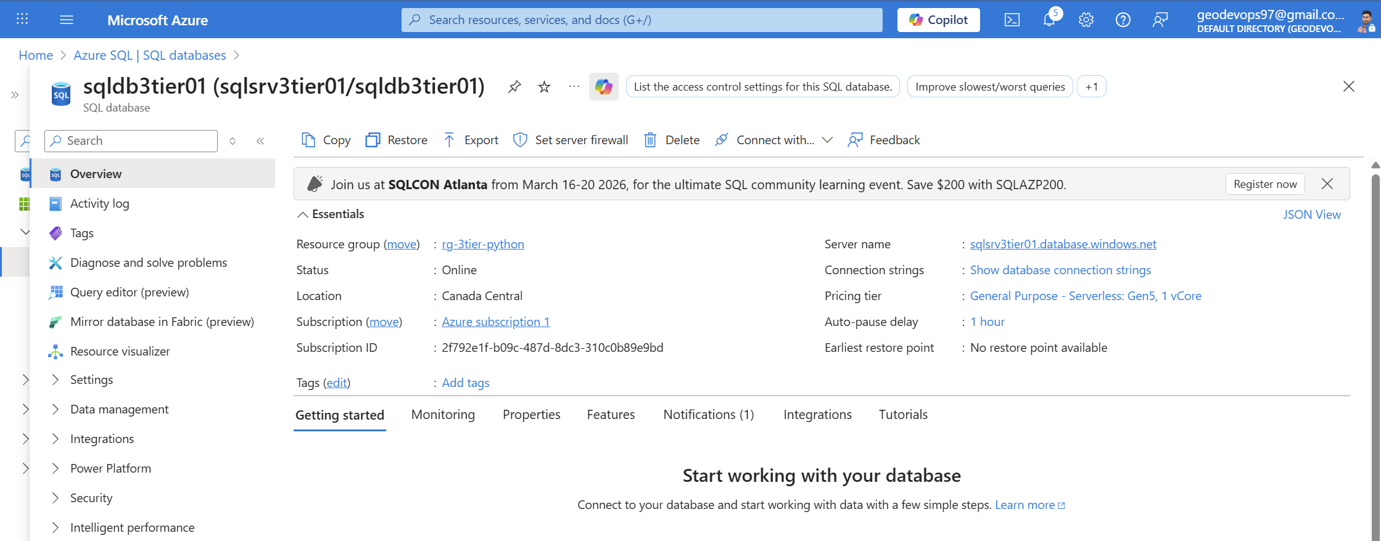

4.5 Temporary Admin Access (Initial Setup)
To create database objects: - Selected networks enabled temporarily - Admin IP added to firewall rules - Azure services access enabled
This access is removed after setup.
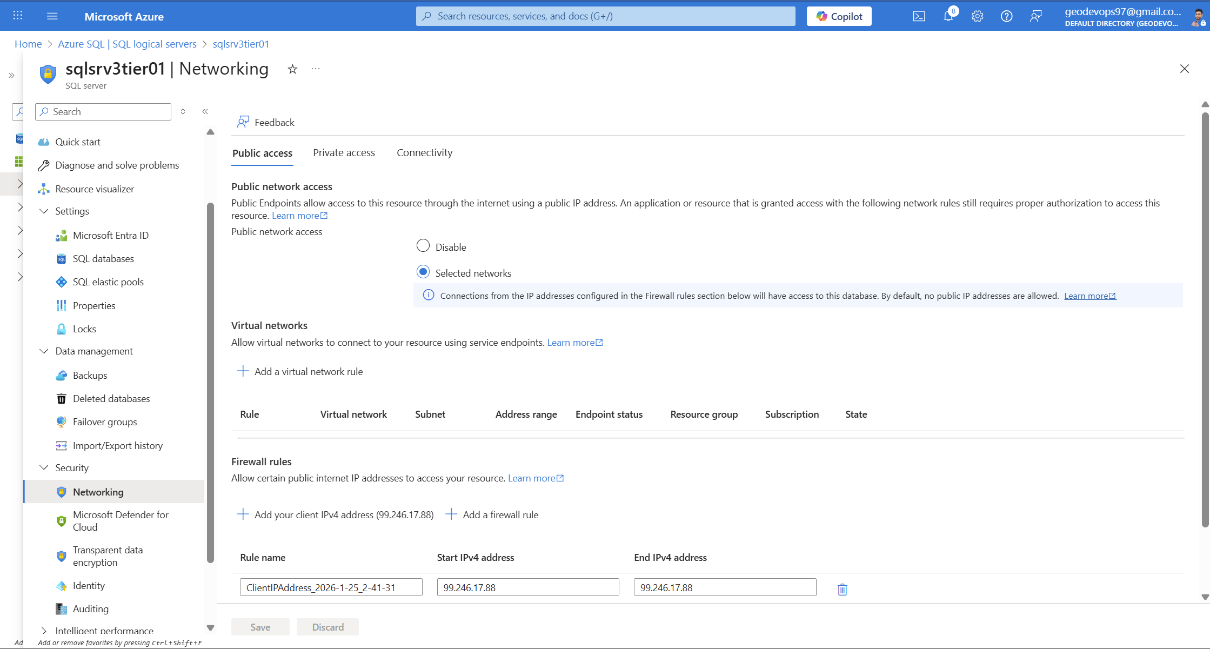

4.6 Database Table Creation
CREATE TABLE dbo.UserSubmissions (
Id INT IDENTITY(1,1) PRIMARY KEY,
FullName NVARCHAR(100) NOT NULL,
Email NVARCHAR(150) NOT NULL,
Message NVARCHAR(500) NULL,
CreatedAt DATETIME2 NOT NULL DEFAULT SYSDATETIME()
);
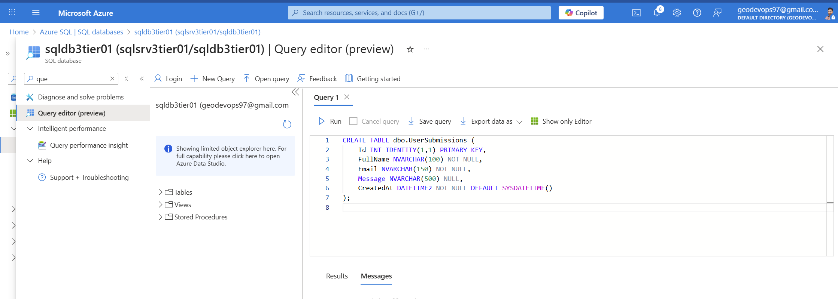

5. App Service Deployment

5.1 App Service Plan
- Linux
- SKU: B1 (Upgradeable)
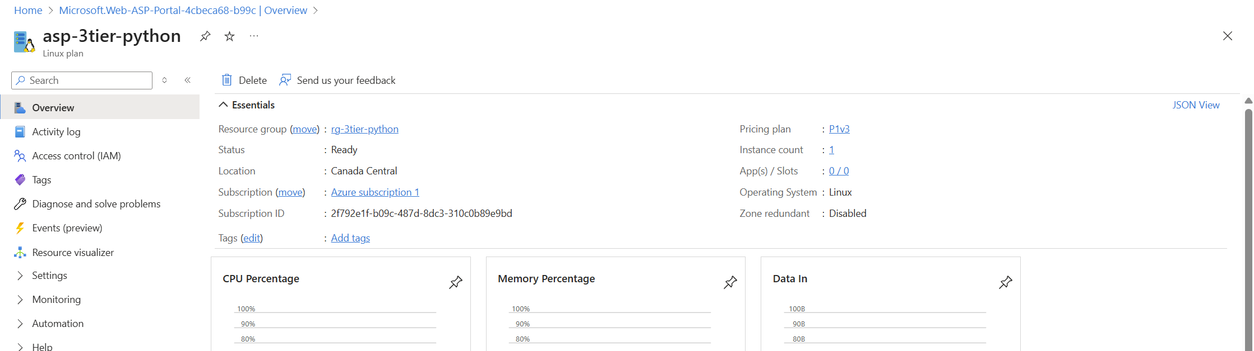

5.2 Backend App Service
- Runtime: Python 3.10/3.11
- Startup Command:
python -m uvicorn main:app --host 0.0.0.0 --port 8000
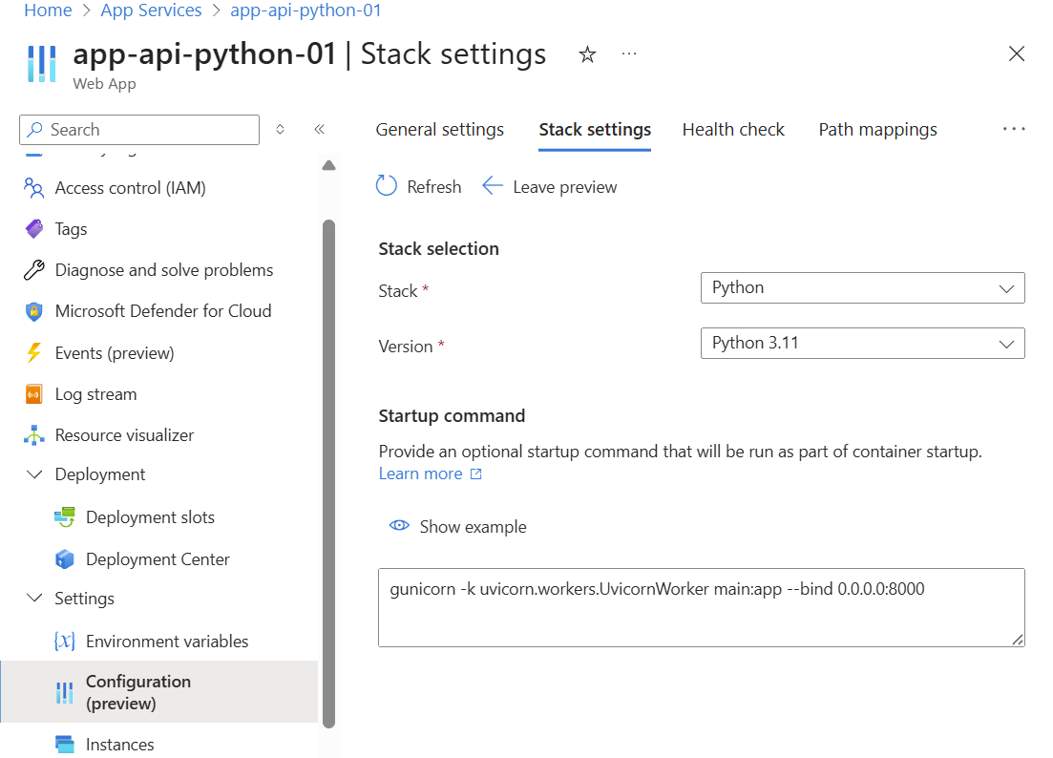

VNet Integration
- Connected to snet-app
- Enables access to Azure SQL private endpoint
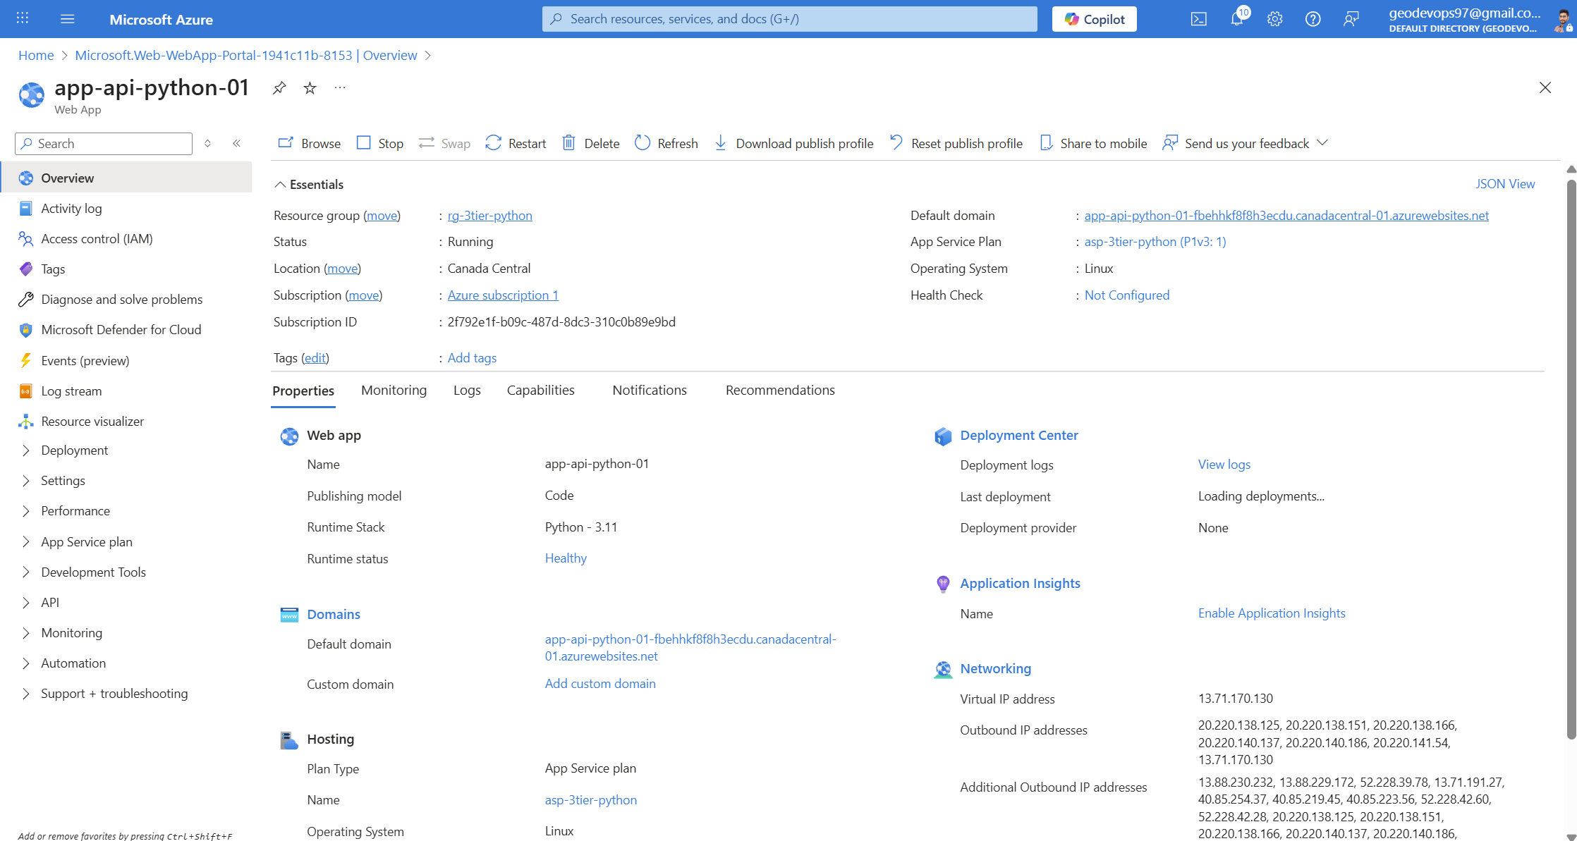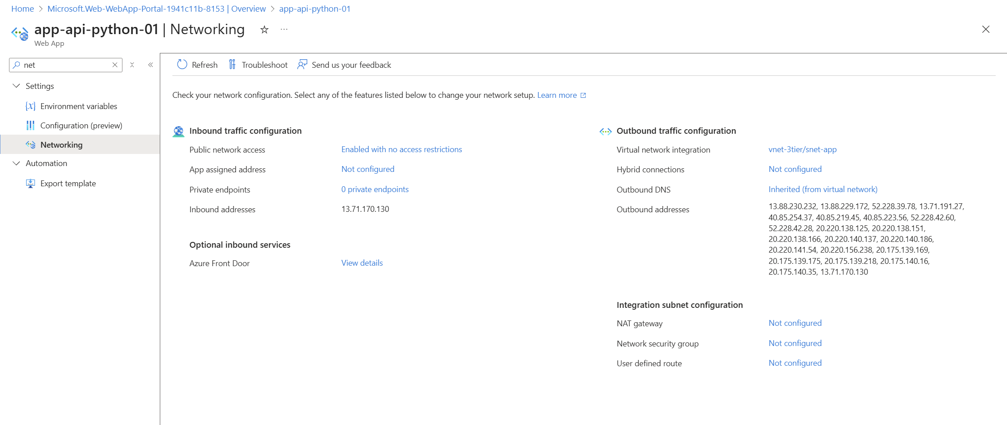

5.3 Backend Configuration
Environment Variables - SQL_CONN_STR - SCM_DO_BUILD_DURING_DEPLOYMENT=1
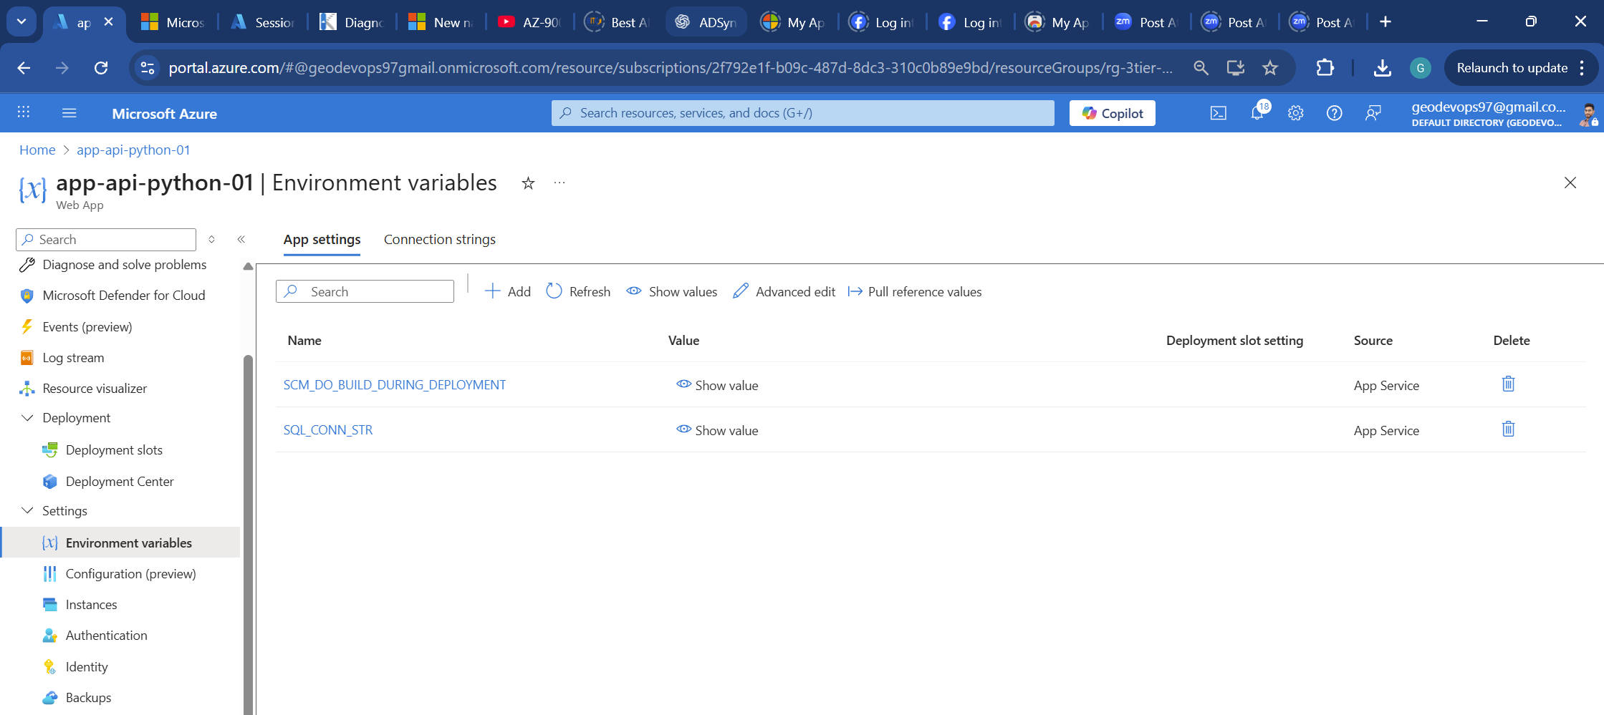

5.4 Backend Deployment
- ZIP deployment via Deployment Center
- Verified files using Kudu console
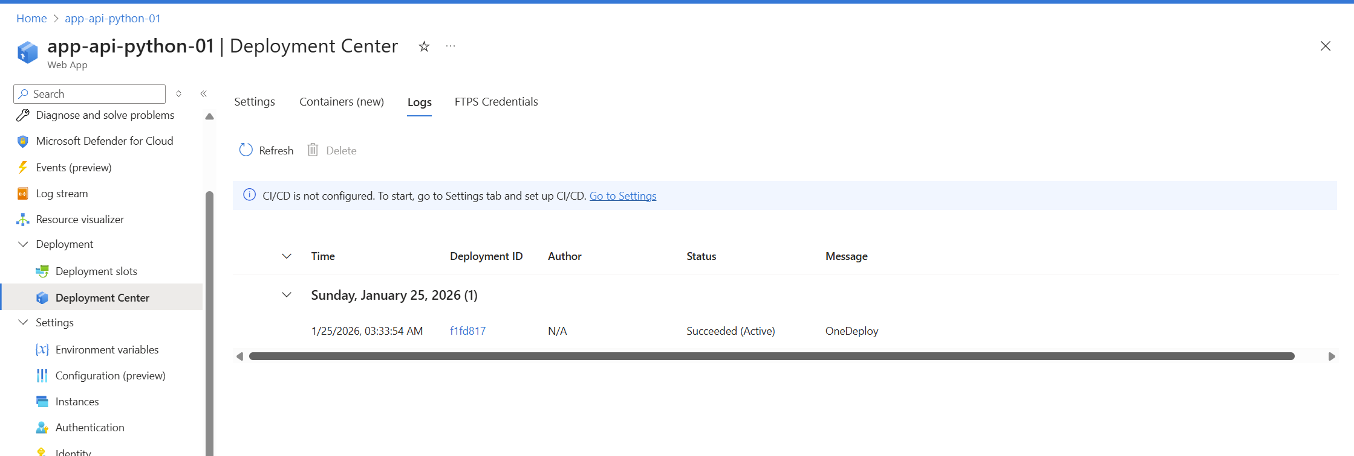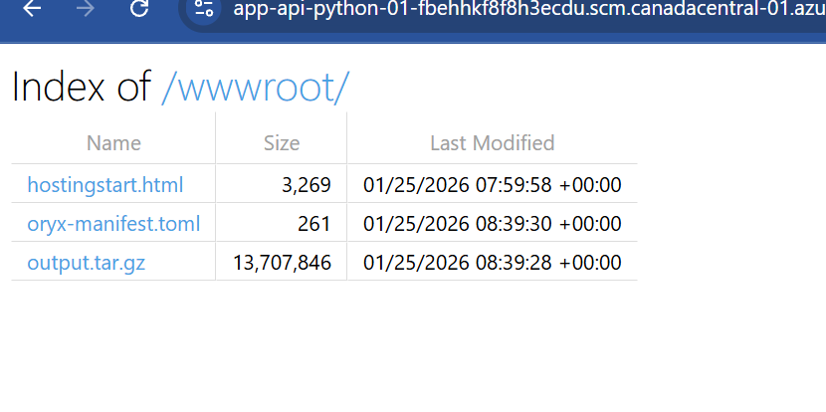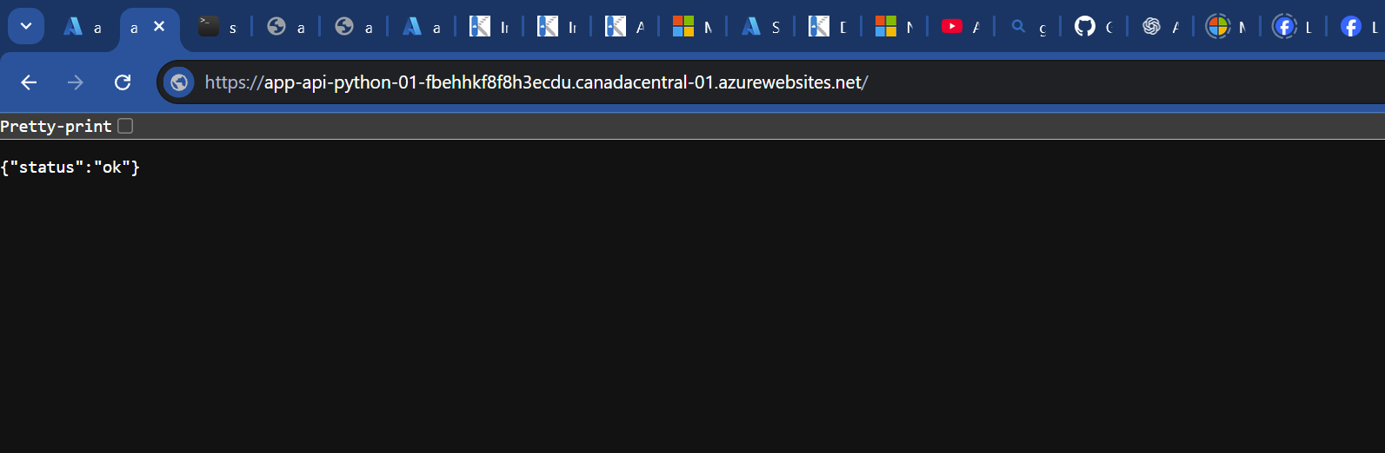

5.5 Frontend App Service
- Runtime: Python
- Startup Command:
gunicorn --bind=0.0.0.0 --timeout 600 app:app
Environment Variables - API_BASE_URL - SCM_DO_BUILD_DURING_DEPLOYMENT=true
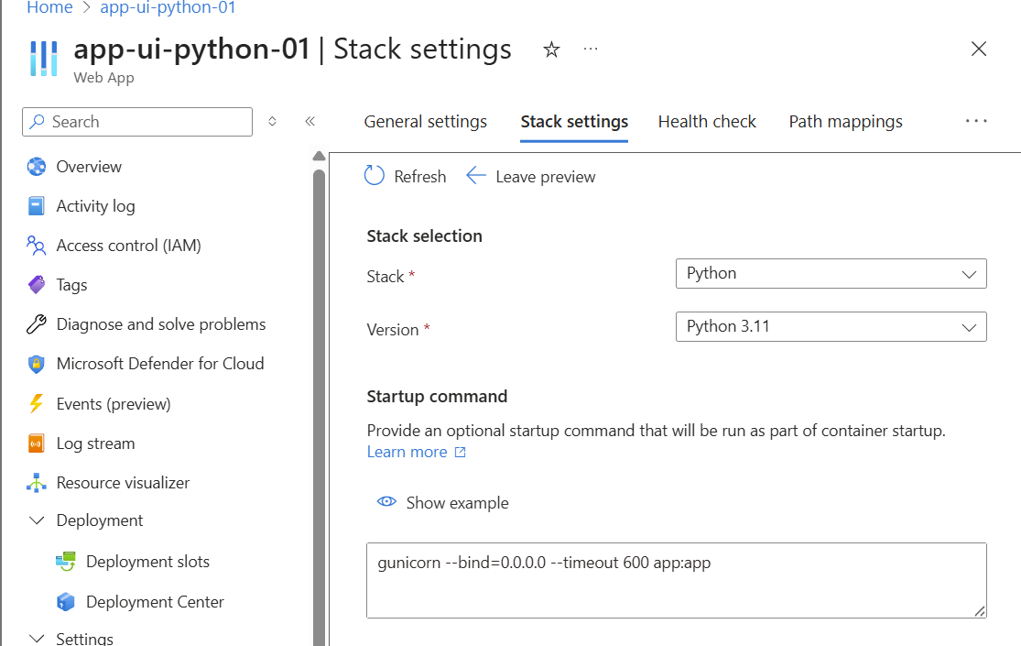
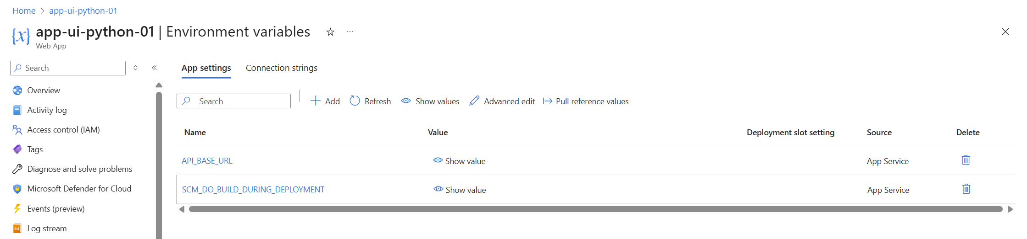

5.6 Frontend Deployment
- ZIP deployment
- Templates folder verified in Kudu
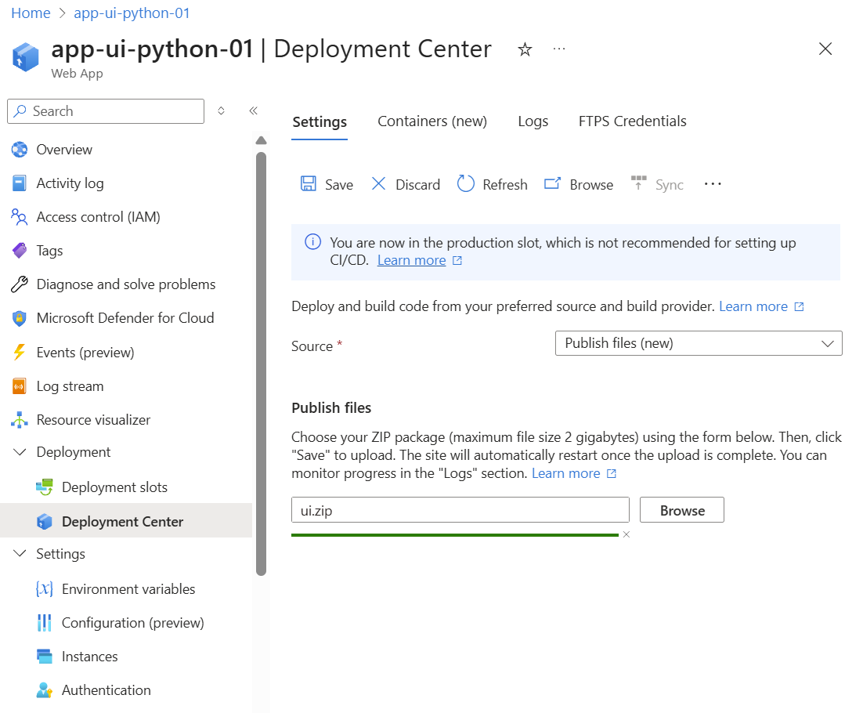

6. Validation & Testing

6.1 Backend Health Check
https://<backend-app-url>/health
Expected Output:
{"status": "ok"}

6.2 End‑to‑End Test
- Open UI App Service URL
- Submit form
- Data is sent to backend
- Backend writes to SQL Database via private endpoint
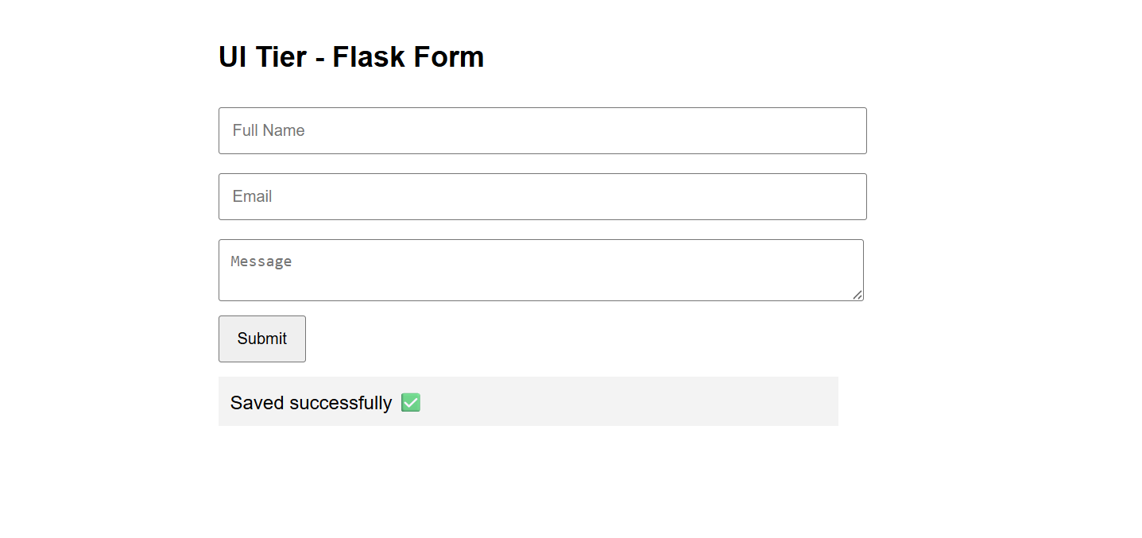

6.3 Database Verification
SELECT * FROM dbo.UserSubmissions
ORDER BY CreatedAt DESC;
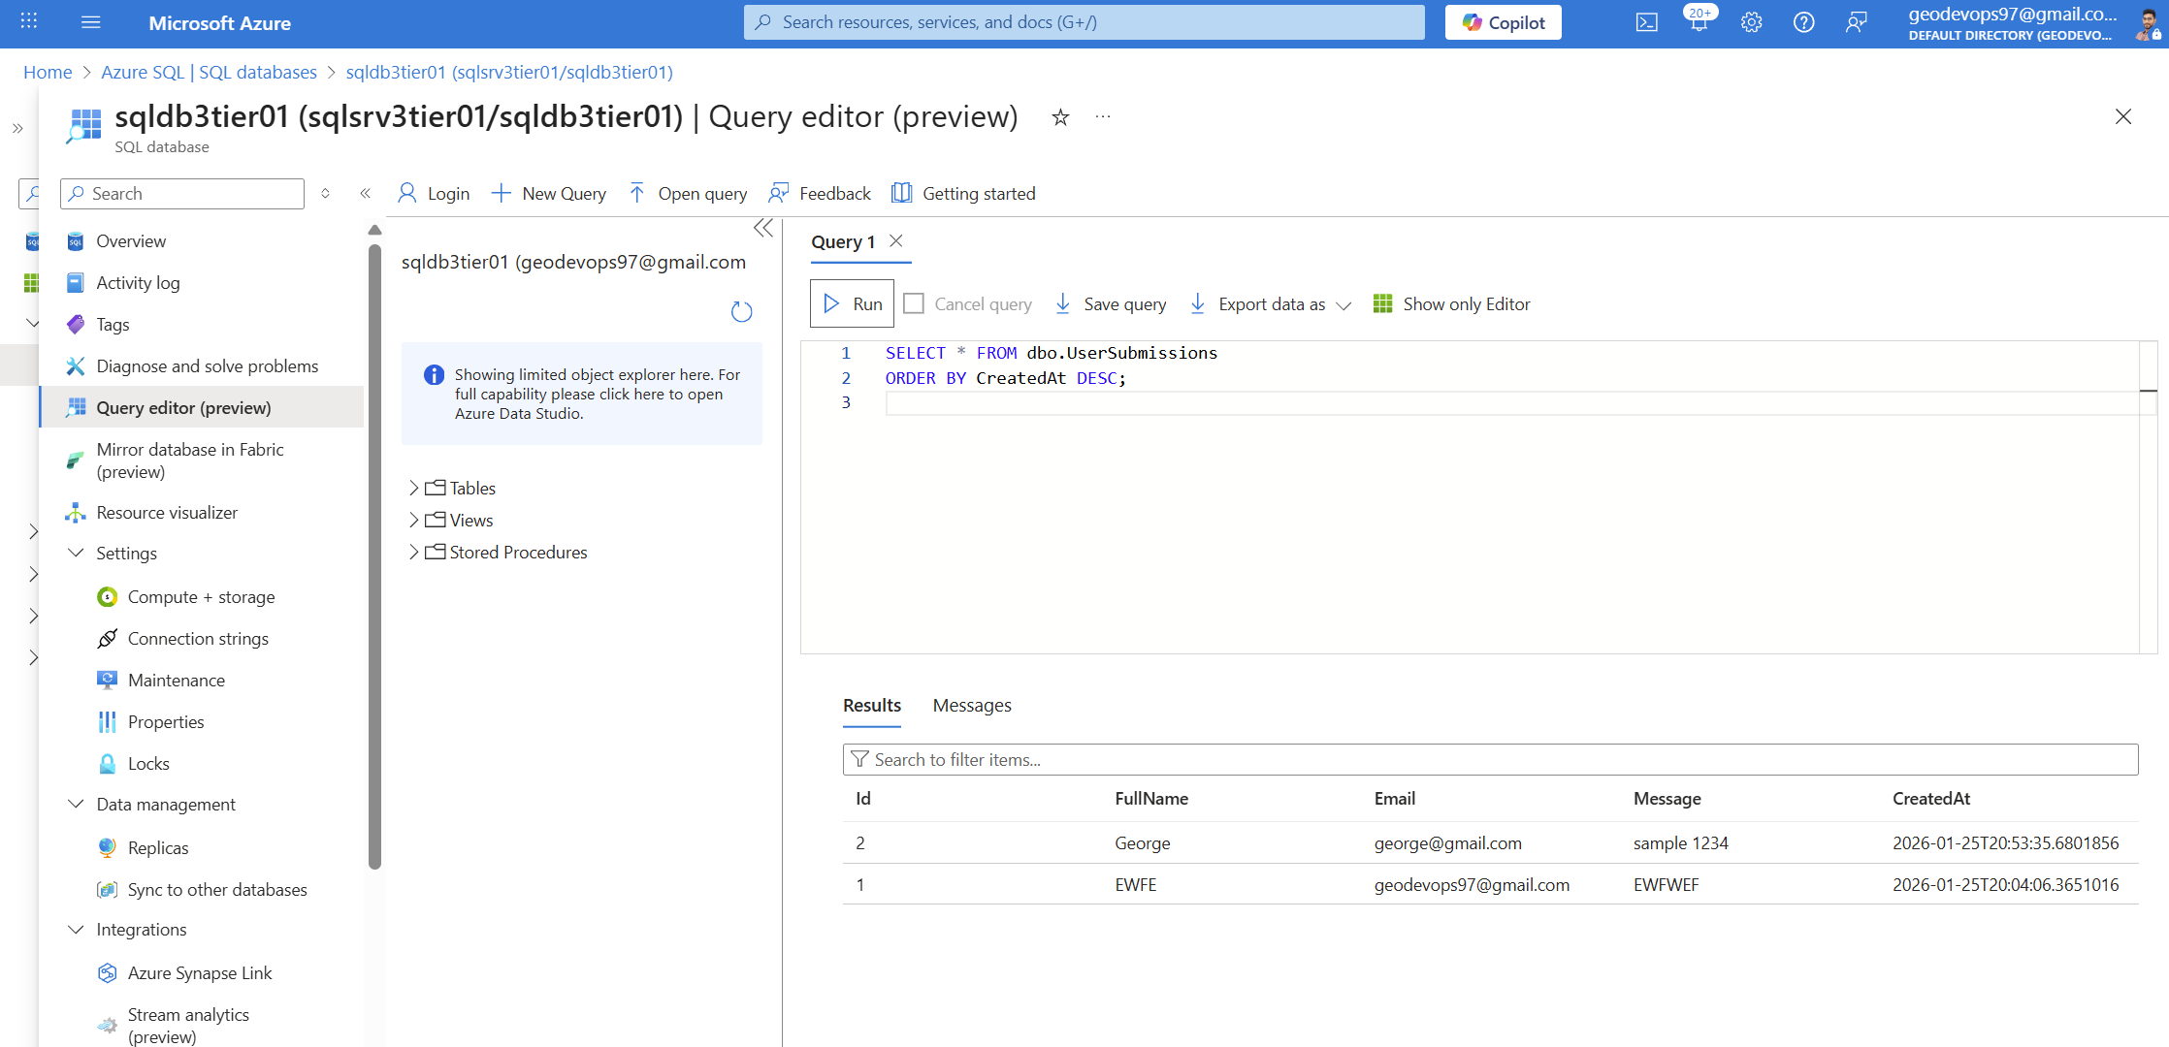

7. Security Highlights
- No database public exposure
- Backend isolated via VNet
- Secrets stored in App Service environment variables
- No hardcoded credentials
- Private DNS resolution

8.Limitations & Future Enhancements
Current Limitations: - SQL authentication instead of Managed Identity - Basic SKU for demo purposes
Future Enhancements: - Use Managed Identity for SQL access - Add Application Insights - Enable HTTPS-only and WAF - CI/CD with GitHub Actions or Azure DevOps - Role-based access control (RBAC)

9. Conclusion
This project demonstrates a production‑ready Azure 3‑tier architecture using fully managed PaaS services while maintaining strong security boundaries. It is suitable for: - Enterprise demos - Azure interviews - Security‑focused architecture walkthroughs - POCs and training

Project Status: ✅ Successfully Implemented
10. Architecture Diagram
